Mad Libs psp-02-02

Anthony Peloso, Daniel Williamson

09/10/2015

Section 3

1. Write a Mad Lib with at least 12 questions and 10 lines to your story. The 12 questions consist of verbs, nouns, or adjectives. Start off Mad Lib with inputting words based on what’s asked.

* input
* print

1. Figure out where the input is in the story. If input is either a noun, verb, or adjective. Start by writing inputs for each of our 12 questions. Then, use the print function to write our story and concatenate our inputs within it.

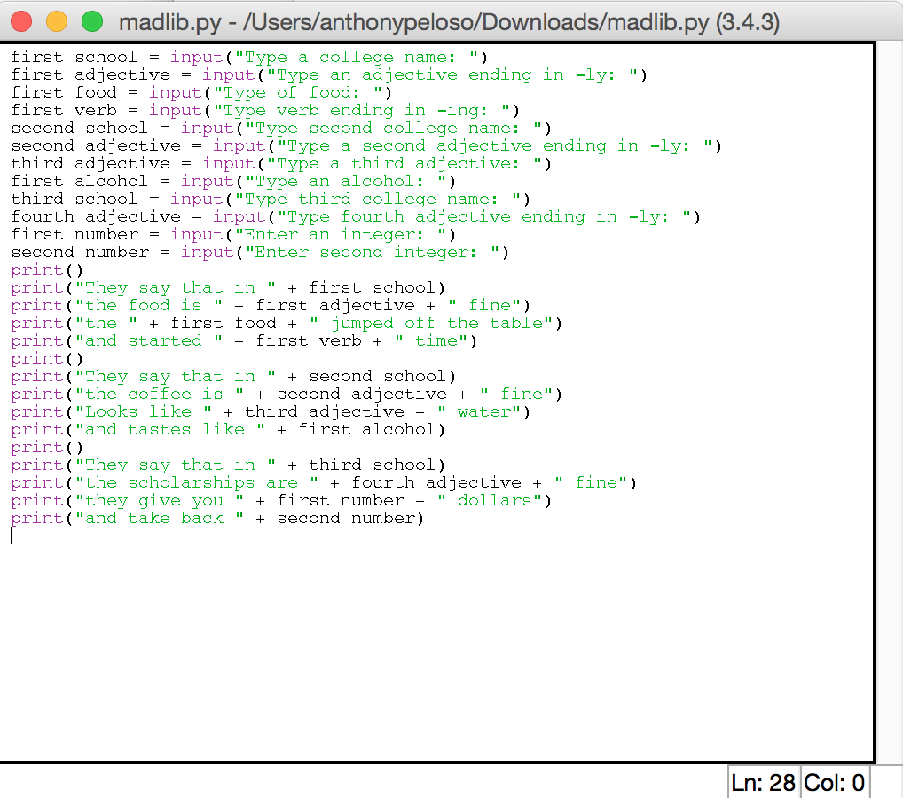

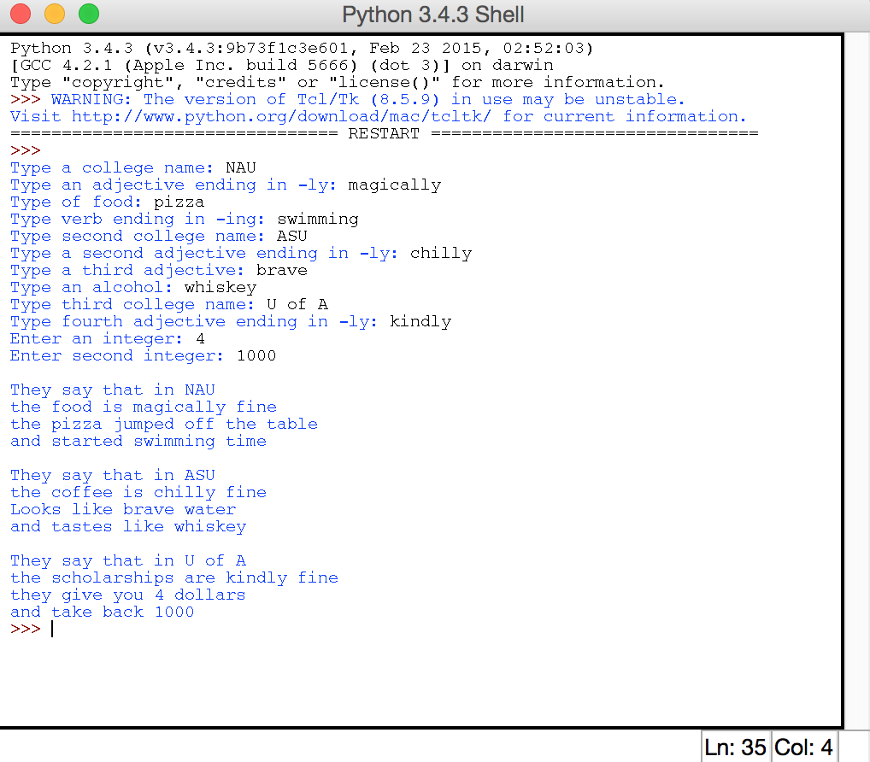

1. Our code was pretty clean and effective. We easily spotted issues and corrected them. Input and print were a crucial to our code. Planning ahead and writing what we wanted before starting helped us code easily.